Partial / residual correlation: NZDUSD and USDJPY
Method 07 / daily log returns / leave-currency-out USD factor / Alpari D1 full available history

Study setup
Logical pair: NZDUSD , USDJPY
Broker symbols: NZDUSD_i , USDJPY_i
Snapshot: 2026-11-03_majors_alpari_D1
Timeframe: D1
Matched return window: 1999-01-05 to 2026-11-02 (UTC bar dates)
Matched return count n: 7148
Dropped unfinished last bar dated 2026-11-03 UTC after a tick-volume check against the prior complete day.
USD-strength sign rule: minus log return when USD is the quote (EURUSD, GBPUSD, AUDUSD, NZDUSD); plus log return when USD is the base (USDJPY, USDCHF, USDCAD). EURGBP is never a constituent.
Control z constituents (5): EURUSD, GBPUSD, AUDUSD, USDCHF, USDCAD
z_t = equal-weight mean of those USD-strength returns on the same day
Complete matched rows (Excel): NZDUSD-USDJPY_Partial_D1.xlsx
Complete matched rows (HTML table): NZDUSD-USDJPY_Partial_D1_data.html

Method carried forward
Partial / residual correlation regresses each matched daily log return of close, ln(close_t / close_t-1), on the same leave-currency-out USD strength factor z, then takes Pearson correlation of the two residual series. Quotes are not inverted. z is the equal-weight mean of USD-strength returns from other majors that do not share a non-USD currency with either leg; EURGBP is never a constituent. USD-strength is minus the log return when USD is the quote (EURUSD, GBPUSD, AUDUSD, NZDUSD) and plus the log return when USD is the base (USDJPY, USDCHF, USDCAD). OLS uses an intercept on each leg. rho_partial is symmetric under swap of the two symbols. It describes leftover linear co-movement after removing linear z; it is not a cause, not a lead, and not a trading signal. Daily rows are not independent and residuals are estimated, so the two-sided p-value and Fisher interval are secondary. Same-sample raw Pearson r is a side check only.

Regression on z
leg | intercept_a_or_c | slope_b_or_d | R2
NZDUSD | -2.39e-06 | -1.1805029 | 0.55837365
USDJPY | 5.873e-05 | 0.33244215 | 0.06713494

Results
rho_partial: 0.092999
Two-sided p-value: 3.31662e-15
Approximate 95% Fisher interval: [0.069967, 0.115932]
Same-sample raw Pearson r: -0.133922
rho_partial minus r: 0.226921

Conclusion
Over 7148 matched daily rows for NZDUSD and USDJPY after removing a leave-currency-out USD factor built from 5 constituents, rho_partial is 0.0930 (positive, weak residual linear link in this sample). Approximate 95% Fisher interval: [0.0700, 0.1159]. Same-sample raw Pearson r is -0.1339 (partial minus r = 0.2269). Leg R-squared on z: NZDUSD=0.5584, USDJPY=0.0671. Two-sided p under the usual independent-pairs model is 3.317e-15; residuals are estimated and daily FX rows are linked, so treat p as secondary. This does not establish cause, lead-lag, or a lasting trading rule.

Charts
Daily closes
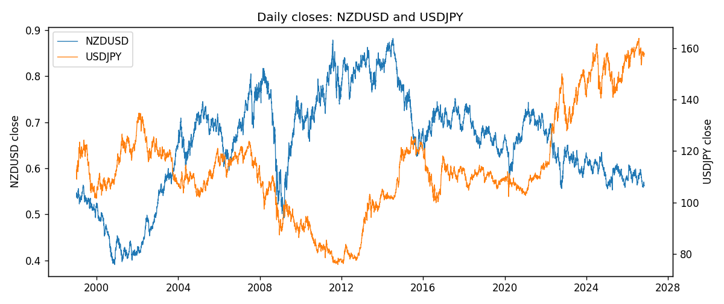
Log returns and control z
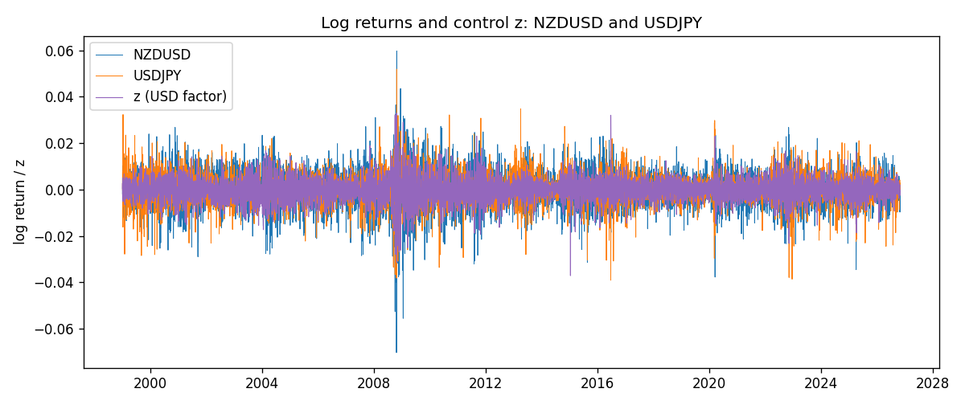
Residual scatter e_x vs e_y
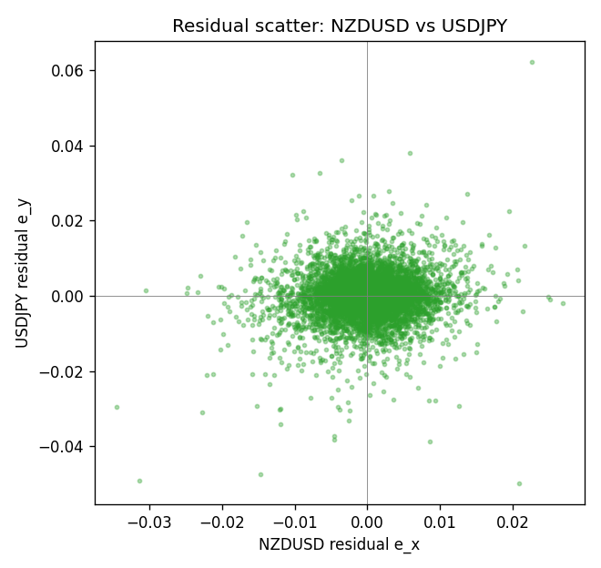

Data report
Every matched row that entered the partial correlation is stored in the sibling Excel workbook named NZDUSD-USDJPY_Partial_D1.xlsx. That file is the complete data archive for redrawing charts. Embedding all rows as a Word table is impractical at this length; the Word file holds the column list, column summaries, and the first and last 15 matched rows.
Columns: time, NZDUSD_open, USDJPY_open, NZDUSD_high, USDJPY_high, NZDUSD_low, USDJPY_low, NZDUSD_close, USDJPY_close, NZDUSD_tick_volume, USDJPY_tick_volume, NZDUSD_spread, USDJPY_spread, NZDUSD_real_volume, USDJPY_real_volume, NZDUSD_log_return, USDJPY_log_return, usd_strength_EURUSD, usd_strength_GBPUSD, usd_strength_AUDUSD, usd_strength_USDCHF, usd_strength_USDCAD, z, NZDUSD_fitted, USDJPY_fitted, NZDUSD_resid, USDJPY_resid
Column summaries (matched calculation rows)
column | count | mean | std | min | 25% | 50% | 75% | max
NZDUSD_open | 7148 | 0.65680048 | 0.1080291 | 0.3913 | 0.5917475 | 0.668695 | 0.72504 | 0.88218
USDJPY_open | 7148 | 113.80278 | 19.266728 | 75.693 | 104.3275 | 110.969 | 120.725 | 163.824
NZDUSD_high | 7148 | 0.66072183 | 0.10852081 | 0.3961 | 0.595065 | 0.67222 | 0.729525 | 0.88421
USDJPY_high | 7148 | 114.30008 | 19.328348 | 76.001 | 104.8345 | 111.426 | 121.27175 | 163.978
NZDUSD_low | 7148 | 0.65311385 | 0.10762321 | 0.3897 | 0.588355 | 0.66451 | 0.72113 | 0.87988
USDJPY_low | 7148 | 113.28032 | 19.194266 | 75.402 | 103.8475 | 110.515 | 120.19 | 163.628
NZDUSD_close | 7148 | 0.65687963 | 0.10802405 | 0.3907 | 0.592165 | 0.66876 | 0.72518 | 0.8822
USDJPY_close | 7148 | 113.81631 | 19.281858 | 75.811 | 104.3175 | 110.995 | 120.7025 | 163.851
NZDUSD_tick_volume | 7148 | 69051.458 | 123370.73 | 17 | 5742 | 34119 | 58667.5 | 1127682
USDJPY_tick_volume | 7148 | 106851.22 | 179762.89 | 197 | 10008.25 | 53482.5 | 93111.75 | 1803508
NZDUSD_spread | 7148 | 30.128428 | 25.588679 | 0 | 9 | 17 | 40 | 80
USDJPY_spread | 7148 | 20.16704 | 17.582453 | 0 | 6 | 11 | 30 | 50
NZDUSD_real_volume | 7148 | 1.678526e+10 | 8.5194876e+10 | 0 | 0 | 0 | 0 | 2.705649e+12
USDJPY_real_volume | 7148 | 3.4953653e+10 | 1.6133327e+11 | 0 | 0 | 0 | 0 | 3.8834203e+12
NZDUSD_log_return | 7148 | 1.914e-05 | 0.00764519 | -0.07027433 | -0.00424201 | 0.00023666 | 0.004586 | 0.05966839
USDJPY_log_return | 7148 | 5.267e-05 | 0.00620906 | -0.03908203 | -0.00319392 | 0.00012736 | 0.00340928 | 0.05184024
usd_strength_EURUSD | 7148 | 2.16e-06 | 0.0058013 | -0.03433183 | -0.00325609 | -0 | 0.00324218 | 0.03123819
usd_strength_GBPUSD | 7148 | 1.992e-05 | 0.00564699 | -0.03112653 | -0.00318167 | -3.426e-05 | 0.0031217 | 0.08388241
usd_strength_AUDUSD | 7148 | -3.157e-05 | 0.00755018 | -0.0806166 | -0.00415111 | -0.00029168 | 0.00385014 | 0.08602525
usd_strength_USDCHF | 7148 | -6.945e-05 | 0.0065937 | -0.19545699 | -0.00334697 | 8.15e-05 | 0.00331954 | 0.09051364
usd_strength_USDCAD | 7148 | -1.226e-05 | 0.00514518 | -0.03859748 | -0.00283513 | 4.873e-05 | 0.00272781 | 0.03436319
z | 7148 | -1.824e-05 | 0.00483932 | -0.03711018 | -0.00272722 | -3.04e-06 | 0.00271097 | 0.0329285
NZDUSD_fitted | 7148 | 1.914e-05 | 0.00571283 | -0.03887458 | -0.0032027 | 1.2e-06 | 0.0032171 | 0.04380628
USDJPY_fitted | 7148 | 5.267e-05 | 0.00160879 | -0.01227826 | -0.00084791 | 5.772e-05 | 0.00095997 | 0.01100555
NZDUSD_resid | 7148 | -0 | 0.00508061 | -0.0344479 | -0.00277824 | 0.00012284 | 0.00291454 | 0.02680963
USDJPY_resid | 7148 | 0 | 0.00599702 | -0.04978008 | -0.0029057 | 0.00012833 | 0.00302375 | 0.06220423
First 15 matched rows (selected columns)
time | NZDUSD_close | USDJPY_close | NZDUSD_log_return | USDJPY_log_return | z | NZDUSD_fitted | USDJPY_fitted | NZDUSD_resid | USDJPY_resid
1999-01-05 | 0.5372 | 111.92 | -0.0018597736 | -0.00017868311 | 0.00046953395 | -0.00055667689 | 0.0002148226 | -0.0013030968 | -0.00039350571
1999-01-06 | 0.5383 | 112.77 | 0.0020455609 | 0.0075660159 | 0.0027182225 | -0.0032112602 | 0.00096238147 | 0.0052568211 | 0.0066036344
1999-01-07 | 0.5417 | 111.33 | 0.0062963171 | -0.012851583 | -0.004448511 | 0.0052490893 | -0.0014201428 | 0.0010472278 | -0.01143144
1999-01-08 | 0.5414 | 110.8 | -0.00055396548 | -0.0047719894 | 0.0050947615 | -0.0060167713 | 0.0017524432 | 0.0054628058 | -0.0065244326
1999-01-11 | 0.547 | 109.02 | 0.010290425 | -0.016195423 | 0.0014699162 | -0.001737631 | 0.00054739183 | 0.012028056 | -0.016742815
1999-01-12 | 0.5441 | 112.6 | -0.0053157489 | 0.032310364 | -0.0010246625 | 0.0012072263 | -0.00028191128 | -0.0065229752 | 0.032592275
1999-01-13 | 0.5387 | 113.52 | -0.0099742238 | 0.0081373171 | -0.0051611711 | 0.0060903865 | -0.0016570611 | -0.01606461 | 0.0097943782
1999-01-14 | 0.5386 | 113.52 | -0.00018564931 | 0 | 0.0010542537 | -0.0012469402 | 0.00040920809 | 0.0010612909 | -0.00040920809
1999-01-15 | 0.5382 | 114.15 | -0.00074294208 | 0.0055343401 | 0.0034075355 | -0.0040249961 | 0.0011915381 | 0.003282054 | 0.004342802
1999-01-18 | 0.5372 | 114.16 | -0.0018597736 | 8.7600193e-05 | -0.0015970105 | 0.0018828848 | -0.00047218389 | -0.0037426584 | 0.00055978408
1999-01-19 | 0.5382 | 113.52 | 0.0018597736 | -0.0056219403 | -0.001249739 | 0.0014729298 | -0.0003567362 | 0.00038684387 | -0.0052652041
1999-01-20 | 0.5404 | 112.91 | 0.0040793678 | -0.0053879917 | 0.0016219654 | -0.0019171255 | 0.00059793938 | 0.0059964933 | -0.005985931
1999-01-21 | 0.5426 | 113.87 | 0.0040627941 | 0.0084664056 | -0.003012007 | 0.0035532921 | -0.00094258835 | 0.000509502 | 0.009408994
1999-01-22 | 0.5361 | 114.56 | -0.012051689 | 0.0060412564 | 0.0026686621 | -0.003152754 | 0.00094590549 | -0.0088989354 | 0.0050953509
1999-01-25 | 0.5342 | 113.72 | -0.0035504102 | -0.0073594164 | 0.0018176408 | -0.0021481208 | 0.00066299013 | -0.0014022893 | -0.0080224066
Last 15 matched rows (selected columns)
time | NZDUSD_close | USDJPY_close | NZDUSD_log_return | USDJPY_log_return | z | NZDUSD_fitted | USDJPY_fitted | NZDUSD_resid | USDJPY_resid
2026-10-13 | 0.56127 | 158.305 | 0.0047326165 | -0.0018932826 | -0.0036039252 | 0.0042520533 | -0.0011393669 | 0.00048056317 | -0.00075391565
2026-10-14 | 0.55918 | 158.317 | -0.0037306483 | 7.5800166e-05 | 0.0029302645 | -0.0034615763 | 0.0010328732 | -0.00026907192 | -0.00095707299
2026-10-15 | 0.56185 | 158.024 | 0.0047634855 | -0.0018524319 | -0.0036107856 | 0.004260152 | -0.0011416476 | 0.0005033334 | -0.00071078432
2026-10-16 | 0.56509 | 157.964 | 0.0057501001 | -0.00037976126 | -0.0031955249 | 0.0037699356 | -0.0010035975 | 0.0019801645 | 0.00062383619
2026-10-19 | 0.56616 | 158.517 | 0.0018917133 | 0.0034946841 | 0.00019102818 | -0.00022790003 | 0.00012223554 | 0.0021196133 | 0.0033724486
2026-10-20 | 0.56827 | 158.16 | 0.0037199341 | -0.0022546642 | -0.0035554555 | 0.0041948347 | -0.0011232535 | -0.00047490053 | -0.0011314107
2026-10-21 | 0.57003 | 158.108 | 0.0030923331 | -0.00032883504 | -0.0011561992 | 0.0013625058 | -0.00032563963 | 0.0017298274 | -3.195415e-06
2026-10-22 | 0.56815 | 156.755 | -0.0033035227 | -0.0085942669 | -0.00095922186 | 0.0011299734 | -0.00026015605 | -0.0044334961 | -0.0083341108
2026-10-23 | 0.56991 | 156.81 | 0.0030929853 | 0.00035080446 | 0.0013515438 | -0.001597892 | 0.00050803984 | 0.0046908773 | -0.00015723538
2026-10-26 | 0.56826 | 157.458 | -0.0028993932 | 0.0041238746 | 0.0019611815 | -0.0023175711 | 0.00071070911 | -0.00058182209 | 0.0034131655
2026-10-27 | 0.56811 | 157.894 | -0.00026399852 | 0.0027651658 | 0.0019996384 | -0.0023629696 | 0.00072349382 | 0.0020989711 | 0.002041672
2026-10-28 | 0.56261 | 157.743 | -0.0097283914 | -0.00095679538 | -0.0025494332 | 0.0030072225 | -0.00078880933 | -0.012735614 | -0.00016798605
2026-10-29 | 0.56296 | 157.683 | 0.00062190714 | -0.00038043789 | -0.0013472312 | 0.0015880196 | -0.0003891467 | -0.00096611241 | 8.7088148e-06
2026-10-30 | 0.56307 | 157.516 | 0.00019537668 | -0.0010596481 | -0.00030467629 | 0.00035728052 | -4.2557514e-05 | -0.00016190384 | -0.0010170906
2026-11-02 | 0.56161 | 157.933 | -0.0025962955 | 0.0026438521 | -0.00096599592 | 0.0011379702 | -0.00026240803 | -0.0037342658 | 0.0029062601

